Use-Case Realization Report
Take Lesson

Issue <1.0>
Revision History
Date | Issue | Description | Author
<dd/mmm/yy> | <x.x> | <details> | <name>

Table of Contents
1. Brief Description 4
2. Flow of Events 4
2.1 Standard Flow 4
2.2 Exception Flow 4
3. Interaction Diagrams 5
3.1 Collaboration Diagram for Take Lesson 5
4. Participating Objects 5
5. Class Diagrams 7
5.1 Class Diagram for Take Lesson 7
6. Derived Requirements 7

Use-Case Realization Report
Take Lesson

Brief Description

Flow of Events

Standard Flow
- User Logs on to the system.
- According to user’s access rights, system will generate a list of lessons accessible to the user.
- User clicks the link of the lesson he/she is going to take.
- Lesson page will retrieve the lesson and section content to display.
- Meanwhile, lesson page will notify lesson controller the lesson is being taken.
- User finishes the lesson by clicking the logoff button.
- Lesson controller will update the lesson module and the lesson progress as well.

Exception Flow
- If user quite the browser without clicking the logoff button, his/her session will not be cleaned, without saving progress information into the database.

Interaction Diagrams

Collaboration Diagram for Take Lesson
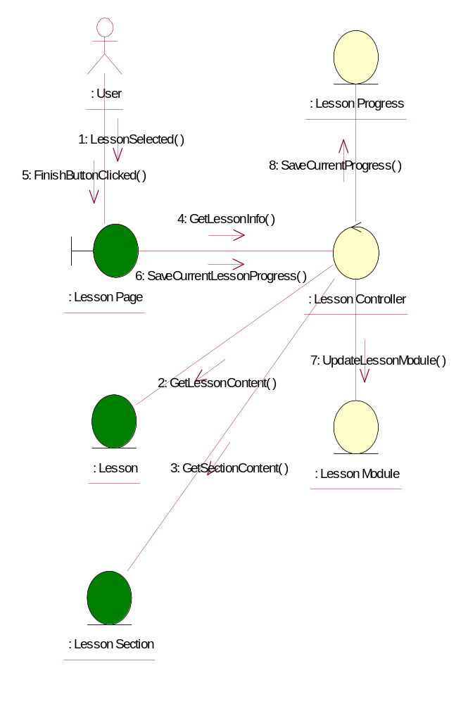

Participating Objects
: Lesson
This entity is the lesson object, it belongs to JMD.
: Lesson Controller
This is the controller to upload, add, delete and modify lessons.
: Lesson Module
This is the object containing the lesson info.
: Lesson Page
Lesson Page is the one from JMD, which in charge of creating lessons.
: Lesson Progress
This entity will record down the progress made by users on the lessons he/she involved in.
: Lesson Section
This entity is the Section object, it belongs to JMD.
: User
This is the end-user of the system

Class Diagrams

Class Diagram for Take Lesson
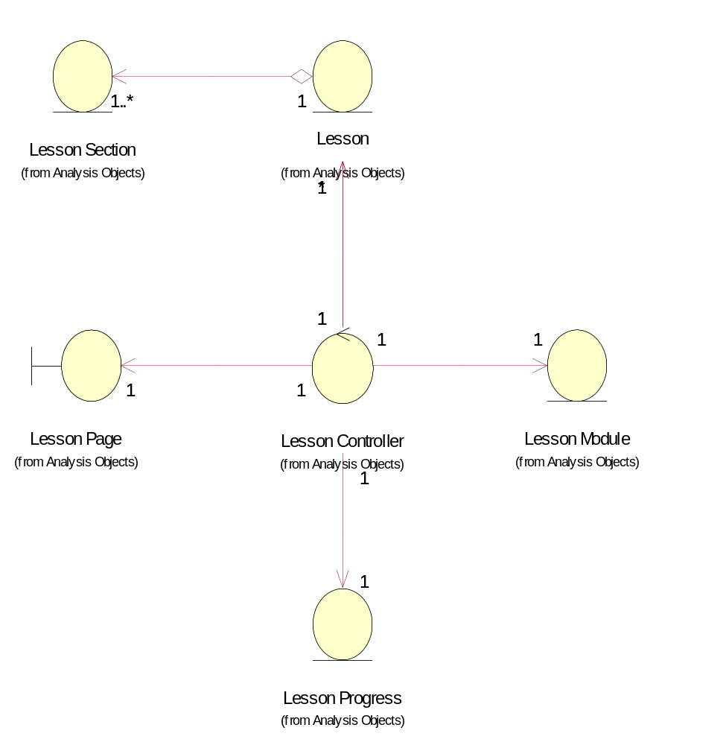

Derived Requirements
In order to take lesson, the user must log in to his/her company site, and must own relevant rights (i.e. The rights of taking lesson) before he/she can proceed with the learning.

